Circuitos Digitais – Exercícios: diagramas de portas lógicas/tabela verdade/formas de onda

1) Para os diagramas de portas lógicas abaixo, obter a expressão correspondente.

a)

b)

2) Considerando o circuito da figura ao lado e as entradas variando conforme mostrado no diagrama de formas de onda abaixo, desenhe no espaço reservado a saída S correspondente.

|  |  |  |  |  |  |  |  |  |  |  |  |  |  |  |  |  |  |  |  |  |  |  |  |  |  |  |  |  |  |  |  |  |  |  |
| --- | --- | --- | --- | --- | --- | --- | --- | --- | --- | --- | --- | --- | --- | --- | --- | --- | --- | --- | --- | --- | --- | --- | --- | --- | --- | --- | --- | --- | --- | --- | --- | --- | --- | --- |
| **B** | | |  |  |  |  |  |  |  |  |  |  |  |  |  |  |  |  |  |  |  |  |  |  |  |  |  |  |  |  |  |  |  |  |
|  |  |  |  |  |  |  |  |  |  |  |  |  |  |  |  |  |  |  |  |  |  |  |  |  |  |  |  |  |  |  |  |  |  |  |
| **A** | | |  |  |  |  |  |  |  |  |  |  |  |  |  |  |  |  |  |  |  |  |  |  |  |  |  |  |  |  |  |  |  |  |
|  |  |  |  |  |  |  |  |  |  |  |  |  |  |  |  |  |  |  |  |  |  |  |  |  |  |  |  |  |  |  |  |  |  |  |
| **C** | | |  |  |  |  |  |  |  |  |  |  |  |  |  |  |  |  |  |  |  |  |  |  |  |  |  |  |  |  |  |  |  |  |
|  |  |  |  |  |  |  |  |  |  |  |  |  |  |  |  |  |  |  |  |  |  |  |  |  |  |  |  |  |  |  |  |  |  |  |
| **S** | | |  |  |  |  |  |  |  |  |  |  |  |  |  |  |  |  |  |  |  |  |  |  |  |  |  |  |  |  |  |  |  |  |

1. Para cada tabela verdade abaixo, projete um circuito lógico, que se comportará de acordo com a tabela-verdade (representar a expressão e o diagrama de portas lógicas)
2. b) c) d)

|  |  |  |  |
| --- | --- | --- | --- |
| A | B | C | S |
| 0 | 0 | 0 | 0 |
| 0 | 0 | 1 | 0 |
| 0 | 1 | 0 | 1 |
| 0 | 1 | 1 | 1 |
| 1 | 0 | 0 | 1 |
| 1 | 0 | 1 | 1 |
| 1 | 1 | 0 | 0 |
| 1 | 1 | 1 | 0 |

|  |  |  |  |
| --- | --- | --- | --- |
| A | B | C | S |
| 0 | 0 | 0 | 0 |
| 0 | 0 | 1 | 1 |
| 0 | 1 | 0 | 1 |
| 0 | 1 | 1 | 0 |
| 1 | 0 | 0 | 1 |
| 1 | 0 | 1 | 1 |
| 1 | 1 | 0 | 0 |
| 1 | 1 | 1 | 0 |

|  |  |  |  |
| --- | --- | --- | --- |
| A | B | C | S |
| 0 | 0 | 0 | 0 |
| 0 | 0 | 1 | 0 |
| 0 | 1 | 0 | 1 |
| 0 | 1 | 1 | 1 |
| 1 | 0 | 0 | 1 |
| 1 | 0 | 1 | 1 |
| 1 | 1 | 0 | 0 |
| 1 | 1 | 1 | 0 |

|  |  |  |  |
| --- | --- | --- | --- |
| A | B | C | S |
| 0 | 0 | 0 | 0 |
| 0 | 0 | 1 | 0 |
| 0 | 1 | 0 | 0 |
| 0 | 1 | 1 | 1 |
| 1 | 0 | 0 | 0 |
| 1 | 0 | 1 | 0 |
| 1 | 1 | 0 | 1 |
| 1 | 1 | 1 | 1 |

1. Escrever a expressão booleana correspondente aos diagramas abaixo:
2. b)

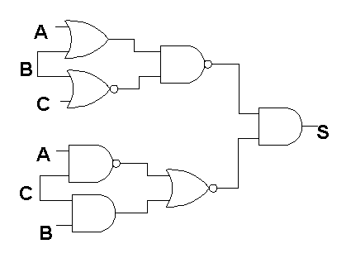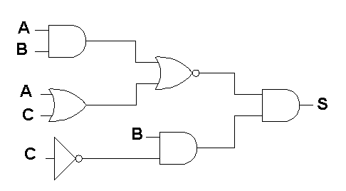

1. d)

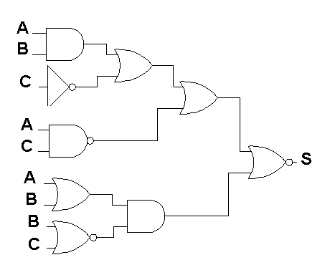

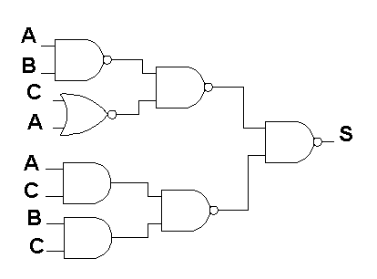

1. Desenhar o diagrama representando cada uma das expressões abaixo;
   1. 
   2. 
   3. 
   4. 
2. Representar a tabela verdade das expressões abaixo:
   1. 

|  |  |  |  |  |  |  |
| --- | --- | --- | --- | --- | --- | --- |
| A | B | C |  |  |  |  |
| 0 | 0 | 0 |  |  |  |  |
| 0 | 0 | 1 |  |  |  |  |
| 0 | 1 | 0 |  |  |  |  |
| 0 | 1 | 1 |  |  |  |  |
| 1 | 0 | 0 |  |  |  |  |
| 1 | 0 | 1 |  |  |  |  |
| 1 | 1 | 0 |  |  |  |  |
| 1 | 1 | 1 |  |  |  |  |

* 1. 

|  |  |  |  |  |  |  |
| --- | --- | --- | --- | --- | --- | --- |
| A | B | C |  |  |  |  |
| 0 | 0 | 0 |  |  |  |  |
| 0 | 0 | 1 |  |  |  |  |
| 0 | 1 | 0 |  |  |  |  |
| 0 | 1 | 1 |  |  |  |  |
| 1 | 0 | 0 |  |  |  |  |
| 1 | 0 | 1 |  |  |  |  |
| 1 | 1 | 0 |  |  |  |  |
| 1 | 1 | 1 |  |  |  |  |

* 1. 

|  |  |  |  |  |  |  |
| --- | --- | --- | --- | --- | --- | --- |
| A | B | C |  |  |  |  |
| 0 | 0 | 0 |  |  |  |  |
| 0 | 0 | 1 |  |  |  |  |
| 0 | 1 | 0 |  |  |  |  |
| 0 | 1 | 1 |  |  |  |  |
| 1 | 0 | 0 |  |  |  |  |
| 1 | 0 | 1 |  |  |  |  |
| 1 | 1 | 0 |  |  |  |  |
| 1 | 1 | 1 |  |  |  |  |

* 1. 

|  |  |  |  |  |  |  |
| --- | --- | --- | --- | --- | --- | --- |
| A | B | C |  |  |  |  |
| 0 | 0 | 0 |  |  |  |  |
| 0 | 0 | 1 |  |  |  |  |
| 0 | 1 | 0 |  |  |  |  |
| 0 | 1 | 1 |  |  |  |  |
| 1 | 0 | 0 |  |  |  |  |
| 1 | 0 | 1 |  |  |  |  |
| 1 | 1 | 0 |  |  |  |  |
| 1 | 1 | 1 |  |  |  |  |

1. Simplificar algebricamente as expressões abaixo, reescrevendo a expressão para cada axioma/teorema aplicado e indicando o número do mesmo na coluna à direita:

a) 

|  |  |
| --- | --- |
|  | No. Axioma ou Teorema |
|  |  |
|  |  |
|  |  |
|  |  |
|  |  |
|  |  |
|  |  |

b) 

|  |  |
| --- | --- |
|  | No. Axioma ou Teorema |
|  |  |
|  |  |
|  |  |
|  |  |
|  |  |
|  |  |
|  |  |

c) 

|  |  |
| --- | --- |
|  | No. Axioma ou Teorema |
|  |  |
|  |  |
|  |  |
|  |  |
|  |  |
|  |  |
|  |  |

d) 

|  |  |
| --- | --- |
|  | No. Axioma ou Teorema |
|  |  |
|  |  |
|  |  |
|  |  |
|  |  |
|  |  |
|  |  |

1. Verifique a equivalência das expressões obtidas com as originais na questão 7) usando tabela verdade.
2. Usando álgebra booleana obter a expressão simplificada para as expressões das questões 4), 5) e 6).